
FACULTY OF COMPUTER SCIENCE AND MATHEMATHICS

BACHELOR OF INFORMATION SYSTEMS (HONS.) INFORMATION SYSTEMS ENGINEERING

OCTOBER 2025 – FEBRUARY 2026

ENTERPRISE PROGRAMMING (CSC584)

USER MANUAL: GREENCYCLE

PREPARED BY:
NAME | STUDENT ID
MUHAMMAD FAREEZ BIN MOHD FAUZI | 2025117949
AIN NUR NADHIRAH BINTI AINOL MURTAZA | 2025120765
AUNI FATIHAH BINTI AUZI | 2025117273
ARNIE SABILA BINTI AHMAD NAJIB | 2025125187

PREPARED FOR:
SIR MUHAMAD RIDHWAN BIN MOHAMAD RAZALI

SUBMISSION DATE:
21st JANUARY 2026

Table of Contents
1. Introduction 1
2. Problem Statement 2
3. Objectives 3
4. Features 4
5. Customer User Manual 6
5.1 Customer Registration 6
5.2 Customer Login 6
5.3 Customer Dashboard 6
5.4 Customer Pickup Request 7
5.5 Customer Profile Management 7
5.5.1 Edit Profile Information 8
5.5.2 Manage Bank Account Information 8
5.5.3 Manage Pickup Addresses 9
5.6 Customer Logout 9
6. Common Staff and Admin User Manuals 10
6.1 Login 10
6.2 Dashboard 10
6.3 Logout 10
7. Staff User Manual 11
7.1 Staff Profile 11
7.2 Request Management 11
8. Admin User Manual 11
8.1 Admin Manage User Management 11
8.1.1 Manage Staff Account 11
8.1.2. Manage Customer Accounts 12
8.2 Rate Management 13
8.3 Request Management 13
Appendix A: Entity-Relationship Diagram 15
Appendix B: Greencycle Flow of Operation 16

Introduction
Greencycle is a community recycling collection system designed to promote sustainability by making recycling more accessible, organized and efficient. This web app allows users to schedule recycling pickup for a variety of recyclable materials which are paper, metal and plastics. Greencycle connects households and recycling collectors through a centralized digital platform, helping minimize waste sent to landfills and promoting environmental responsibility in the community.
The system supports multiple user roles, such as customers, staff and admin, each of which has its own set of functionalities. Customers can register and login to the system, manage their profiles and submit the pickup request. Once a request is submitted, customers can track the status of their requests and view quotation. They can choose whether to accept or reject the offered value. This organized workflow ensures clarity and convenience throughout the recycling process.
For operational purposes, Greencycle provides dashboards for staff and admin to support day-to-day system operations. These dashboards allow authorized users to manage recycling requests, quotations, and recyclable item information, while admins have additional control over users (staff and customers) and recycling rates. Greencycle increases system efficiency and promotes organized and sustainable recycling operations by combining core recycling management functions into a single platform.
For technical architecture, Greencycle is developed using Model-View-Controller (MVC) architectural pattern and the Data Access Object (DAO) framework. Model is represented by JavaBean that defines the data structures of the system. View is the user interface that is built using JavaServer Pages (JSP) integrated with the AdminLTE 3 frontend framework. Controller is managed by Java Servlets which acts as the brain of the system. DAO layer separates the business logic from the database logic (SQL). For hosting and accessibility, Greencycle is fully deployed and accessible via its own dedicated domain at greencycle.site

Problem Statement
Improper waste management and low participation in recycling programs are major environmental issues in many communities. Despite increasing awareness of sustainability, residents frequently struggle to separate recyclable materials, know where to dispose of them, and schedule efficient collection. As a result, recyclable materials like paper, plastics and metals are frequently discarded incorrectly, contributing to environmental pollution, increased landfill usage, and wasted resources.
Furthermore, the lack of a structured system for managing recycling activities results in inefficiencies for both residents and recycling operators. Residents face challenges in scheduling pickups, tracking the status of their recycling, and determining the value of their recyclables. Meanwhile, recycling operators struggle to monitor requests, organize collected materials, and keep accurate records, which reduces operational effectiveness and prevents sustainable waste management initiatives.
This emphasizes the need for solutions that can increase community participation and improve recycling efficiency. This also promotes long-term environmental practices by addressing both user and operational challenges in the recycling process.

Objectives
The objectives of the Greencycle system are as follows:
- To develop a centralized community recycling collection system that allows users to schedule and manage recycling pickup requests efficiently.
- To provide a user-friendly platform that allows customers to manage profiles, addresses and their requests.
- To enable staff and admin to manage pickup requests, recyclable items, quotations and payments.
- To promote organized and sustainable recycling practices by improving operational efficiency, transparency and data management.

Features
The Greencycle system is designed to facilitate a structured and user-friendly recycling collection process in the community. The scope of the system covers functionalities designed for different user roles, ensuring that each role can perform its responsibilities effectively within the recycling workflow.
Customer Features
- Customers can securely create and access their Greencycle accounts through user registration and login functionality.
- Profile management features allow customers to view and update personal information such as their full name, email address, phone number, and password. Customer can add more than one address.
- Pickup address management enables customers to add, edit, delete, and set default pickup addresses for recycling collection.
- Customers can submit recycling pickup requests for metal, plastic, and paper by providing estimated quantities and preferred pickup schedules.
- Customers can view and respond to quotations given for their recycling requests, accepting or rejecting them as needed.
Staff Features
- Secure login and dashboard access to support daily operational tasks including recycling collection and request processing.
- Pickup request management features allow employees to view, update, and process customer recycling pickup requests.
Admin Features
- User management functionality allows administrators to manage both customer and employee accounts within the system.
- Recycling rate adjustment features allow administrators to update recyclable item rates based on operational or market conditions.
- Full system oversight can be obtained through access to pickup requests, recyclable item information, and operational data for monitoring and management.
- Payment processing features to help with the management and updating of payment-related statuses for completed recycling requests.

Customer User Manual

5.1 Customer Registration
- Accesses the Greencycle [include landing page img]
- Clicks Sign up
- System displays the sign-up form [sign up page]
- Enters required details:
- Full name
- Email
- Password
- Phone number
- Clicks Sign Up
- If successful:
- System displays confirmation message [success msg]
- System redirects to login page

5.2 Customer Login
- Accesses the Greencycle
- Clicks Customer Login
- Enter email and password
- Clicks Login
- If credentials are correct:
- System grants access
- Redirect to Customer Dashboard
- If credentials are incorrect:
- System displays error messages

5.3 Customer Dashboard
- Logs into the system
- System displays Customer Dashboard [customer dashboard img]
- Dashboard shows:
- Number of total requests
- Number of totals earned
- Number of Pending requests
- Table that shows a list of Your Current Requests

5.4 Customer Pickup Request
- Select Pickup Requests from sidebar
- System displays the list of pickup requests
- From this page, the customer may perform one of the following actions:
- Add new pickup request
- Clicks Add Request
- Enters pickup details:
- Clicks submit request
- System validates the request information
- If valid:
- System saves the pickup request.
- System sets the request status (e.g. Pending Quotation).
- System displays a confirmation message.
- System returns the customer to the pickup request list.
- View quotation for existing request
- Customer clicks the Action button for a selected pickup request.
- Customer selects View Quote.
- System displays the quotation details.
- Customer chooses one of the following options:
- Accept Quotation:
- Customer clicks Accept.
- System updates the request status (e.g. Quotation Accepted).
- System displays a success message.
- Reject Quotation
- Customer clicks Reject.
- System updates the request status (e.g. Quotation Rejected).
- System displays a confirmation message.

5.5 Customer Profile Management
- Select Profile Management from sidebar
- System displays the customer profile page
- From this page, the customer may perform one of the following actions:

5.5.1 Edit Profile Information
- System displays bank account details
- Updates personal information:
- Full name
- Email
- Phone number
- Password
- Clicks Save
- System validates the updated information
- If valid:
- System updates the customer profile
- System displays a success message

5.5.2 Manage Bank Account Information
    - System displays bank account details
    - Enters or updates:
- Bank account name
- Bank account number
    - Clicks Save
    - System validates the bank account information
    - If valid:
      - Bank account name
      - Bank account number

5.5.3 Manage Pickup Addresses
    - System displays the list of saved pickup addresses, including the default address. From this page, the customer may perform one of the following actions:
- Add new pickup address
- Clicks Add Address
- System displays address forms
- Enters pickup address details
- Clicks Save
- System validates and saves the new address
- Edit pickup address
- Clicks Edit for a selected address
- System displays the address details
- Updates the information
- Clicks Save
- System validates and updates the address
- Delete Pickup Address
- Clicks Delete for a selected address
- System displays a confirmation prompt
- Confirms the deletion
- Clicks Save
- System removes the address from the list
- Set default pickup address
- Click Set Default for a selected address
- System updates the default address

5.6 Customer Logout
- Clicks Logout on the top navigation bar.
- System displays a logout confirmation (optional).
- Confirms the logout action.
- System terminates the user session.
- System redirects the customer to the Login page.

6. Common Staff and Admin User Manuals
(Applies to: Staff and Admin)

6.1 Login
- Accesses the Greencycle
- Clicks Staff Login
- Enter email and password
- Clicks Login
- If credentials are correct:
- System grants access
- Redirect to Staff or Admin Dashboard
- If credentials are incorrect:
- System displays error messages

6.2 Dashboard
- Logs into the system
- System displays Staff or Admin Dashboard [customer dashboard img]
- Dashboard shows:

6.3 Logout
- Clicks Logout on the top navigation bar.
- System displays a logout confirmation.
- Confirms the logout action.
- System terminates the user session.
- System redirects the customer to the Login page.

7. Staff User Manual

7.1 Staff Profile

7.2 Request Management
- Clicks Request Management on the sidebar
- System displays list of requests submitted by customers
- Selects a request and clicks the Reweigh button
- System displays Verify Weights form
- Updates the weight for recyclable items plastic, paper or metal
- Clicks on Save & Quote
- System validates the updated weight information
- If valid:
  - System displays success message
  - System updates the request status from Pending Pickup to Quoted

8. Admin User Manual

8.1 Admin Manage User Management
- Selects User Management from the sidebar
- System displays the User Management with two categories:
  - Staff
  - Customer

8.1.1 Manage Staff Account
i. Selects Staff from the User Management category
ii. System displays the list of staff accounts. From this page, admin may perform one of the following actions:
- Add Staff
- Clicks Add Staff
- System displays add staff form
- Enters staff details:
    - Name
    - Email
    - Phone
- Clicks Save
- System validates the staff information
- If valid:
  - System creates new staff account
  - System displays success message
B. Edit Staff Information
- Clicks pencil icon at the column Actions to Edit for a selected staff
- System displays the staff details
- Updates the required information
- Clicks Save
- System validates the changes
- If valid:
  - System updates the staff account
  - System displays success message
C. Delete Staff
- Clicks trash icon at the column Actions to Delete for a selected staff
- System displays a confirmation prompt
- Confirms the deletion
- Clicks Save
- System removes the staff from the list

8.1.2. Manage Customer Accounts
i. Selects Customer from the User Management category
ii. System displays the list of customer accounts
- Edit Customer Information
- Clicks pencil icon at the column Actions to Edit for a selected staff
- System displays customer details
- Updates the allowed fields
- Clicks Save
- System validates updated information
- If valid:
a. System updates customer account
b. System displays success message

- Delete Customer
- Clicks trash icon at the column Actions to Delete for a selected customer
- System displays a confirmation prompt
- Confirms the deletion
- Clicks Save
- System removes the customer from the list

8.2 Rate Management
- Clicks on Rate Management from the sidebar
- System displays the Current Market Prices for recyclable items
- Select item and updates rate
- Clicks Save All Rates
- System validates updated rates information
- If valid:
a. System updated latest rate information
b. System displays success message

8.3 Request Management
- Clicks Request Management from the sidebar
- System displays list of requests submitted by customers
- Selects a request and clicks the Release Payment button
- System updates the request status from Pending Payment to Completed
- System displays success message

Appendix A: Entity-Relationship Diagram
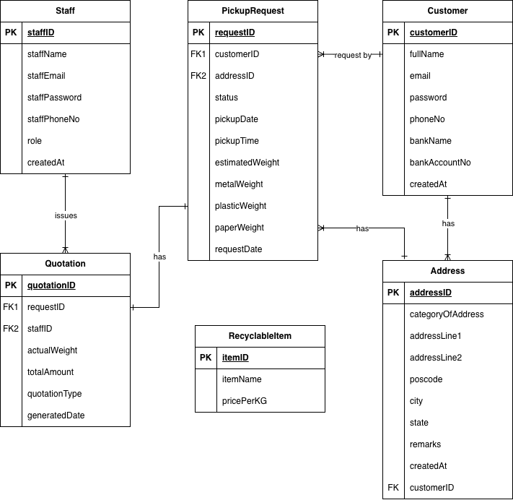

Appendix B: Greencycle Flow of Operation
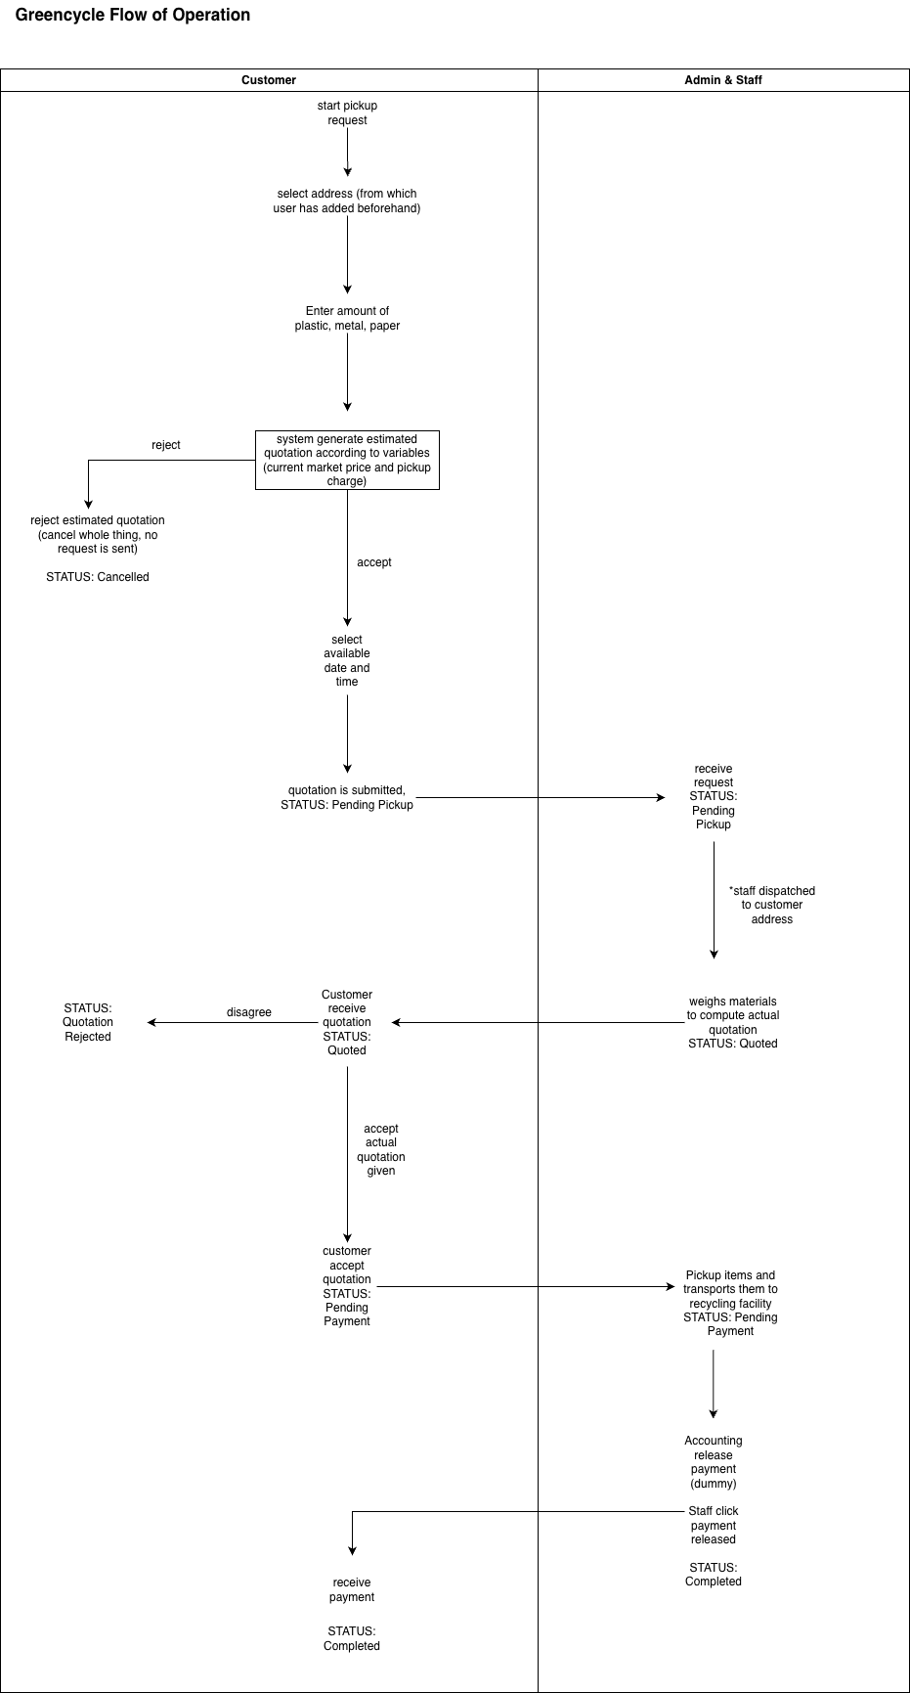
Dumps
6. Recyclable Items
- Select Recyclable Items from sidebar
- System displays the list of recyclable items
From this page, the staff and admin may perform one of the following actions:
- Add New Recyclable Items
    - Clicks Add Item
    - System displays add recyclable item form
    - Add item details:
- Material Name
- Rate per KG (RM)
    - Clicks Save
    - System validates the new information.
    - If valid:
- System displays success message
Clicks pencil icon at the column Actions to Edit for a selected recyclable item
- System displays editable recyclable item field.
- Updates recyclable item information:
a. Material Name
b. Rate per KG (RM)
- Clicks Save
- System validates the updated information
- If valid:
a. System updates the recyclable items list
b. System displays a success message
- Delete Recyclable Item
- Clicks trash icon at the column Actions to Delete for a selected recyclable item
- System displays a confirmation prompt
- Confirms the deletion
- Clicks Save
- System removes the recyclable item from the list

